

SquarePetals Vol.2 SEP 2019
Editorial Board: Satish Verma
Shashwat Johri
Vidya Krishnaraj
Michael Ediale
Sansriti Johri
Concept & Production Chief: Viren Johri
Article Writers:
Sansriti Johri
Vidya Krishnaraj
Revathi Mohan
Mansi Singh Arora
Michael Ediale
Douglas Sandler
Jahnvi Doshi
Annapurna Verma
Purvi Bapat
Kavita Hans
Sai Sriteesh Jammula
Shashwat Johri
Satish C. Verma
Design & Publication: EsquireVJ Publications
Write to us @
info@esquire-vj.com
Views and opinions expressed in this publication are not necessarily those of publishers. Every effort has been made to ensure accuracy of the information published in this issue. EsquireVJ does not take the responsibility for any errors or omission. No part of this publication can be reproduced or published in any form, without prior permission in writing from the publisher.




Squarepetals, Sep 2019

FROM THE DESK OF
EDITOR - IN – CHIEF
Dear Readers,
Almost at the Moon the Chandrayaan! Humanity is progressing crossing over the continents.
With our little effort of bridging the boundaries, we are proud to bring to you the September 2019 edition of SquarePetals, the Global Webzine.
Our objective is to bring forth quality reading material of varied interests and usefulness with effective presentation, which the readers can easily identify with.
Squarepetals aims to provide a sound authentic platform to the educated and the thinkers for presenting their views and ideas. The vision is to bring together the people of different interests and profession to form literary gentry and create a positive uniformity and understanding for one another, worldwide.
We strongly believe that education is the most powerful tool for changing the world, and so we try to raise the issues of social concern for awareness and consequently a possible solution. This month we are expressing concern about women humiliation in parts of the world.
The healthy lifestyle, Balance of Life; Vital Aspects and Vastu Science are valuable guidelines for good health, peace and happiness.
Festive season in India and celebrations are on. A glimpse is presented beautifully in this issue. Food is an inherent part of celebration so let’s relish the Flavor Special recipe. Also find how emotions are expressed beautifully in the Literary Bytes.
Self discipline, career, top trends, style; Fashion section will be interesting read for young readers!
This September issue has in store, infotainment and more! Happy reading.
We welcome your feedback/response, do write to info@esuire-vj.com.
STAY UPDATED & STAY BLESSED.

(Sansriti Johri)


Contents

Ripples is magic of words, with a wealth of emotions; one would love to read in between the lines as well. It is a technically designed bedside book so that people do not put a lot of reading stress on their eyes before going to sleep. The beautiful presentation of words in harmony with the unique picturesque backdrop will attract you into it as soon as you open the book, and will make you connect instantly. And the best part is, you can enjoy reading Ripples on any page you turn to; you don’t have to remember the page number or sequence... just relax, read and treat your mind to something special after the day.
Ripples is not just another book, it is a well thought and programmed concept that tunes your brain with natural thoughts, brings a smile and sets you for a happy sleep. Please remember, the right kind of sleep is important for good health and therefore...
‘Ripples’ is available now...
Ripples 💕your bedside book.
https://www.esquire-vj.com/product-page/ripples-the-bed-side-book
Cover Story
Aditi Jhala ........4

Society
Gossiping.......6
Women Humiliation........26

Personality Development
Power of Self discipline......23

Health n Fitness
Healthy Lifestyle-II......8

Fest Zest
Dahi Handi……....22

Fashion
Prapti Sarbaliya......20

Literary Bytes
I Found Me ..........7
My Birdie Shall Fly Away……12

Experimental Psychology
Balance in Life: Vital Aspects….13

Spirituality
Miracles Happen.........15

Flavour Special
Veggie Fish……......19

Life Style
Vastu Science….......17
Short Stories
The Night of Hell.........25
Hope ……………………….27

Top Trends……….35
Squarepetals, Sep 2019


There is one thing I have always believed in that, “Hardwork and Dedication go together for a successful future”. Hi! This is Aditi Jhala. I’m 21 year old MCom Business Management student, whose interests and heart lie in Modelling. Walking on ramps, putting up a character in front of camera and speaking confidently on stage, give me a kind of Adrenaline rush. The feeing of being able to become a voice of people who are left unheard, gives me immense pleasure!
Basketball and singing are my favourite hobbies in my free time. Basket Ball has taught me to

Aditi Jhala
Miss Diva Gujarat 2018

work in a team and with the team. My singing has taught me to stay calm in all conditions.
Coming to my family, I’m the youngest of all. Being the youngest, I have been the most pampered child. But the one thing I love about my parents is that they never stopped me or my elder sister to pursue whatever we have wanted
to. Being able to do what I do today and that
too with such joy and happiness, is all because of the support I constantly get from them. Being
the youngest has it’s perks, but I have been blessed to have a family that is supportive of my aspirations and dreams.
At the end, all I would say, is - “Follow your heart. The beginnings are always tough. But the outcome is all that you ever wanted and dreamed of. Keep dreaming. Keep working. Keep following your heart. “
“Hardwork and dedication go together for a successful future”
Squarepetals, Sep 2019





Aditi Jhala

Squarepetals, Sep 2019
Gossiping
Unethical….Unwise…
It is easier to be occupied with the lesser important things in life. It’s fine as long as it doesn’t affect the quality time. Educate your children about it and explain it to them that gossiping is human nature; however it should not deteriorate the wellbeing of others and the quality time of self.
When children complain about drawbacks in the society or some shortcomings in their friends, teach them that, just talking about the issues among ourselves will not bring any change. Encourage them to be in action for the healthy improvement of oneself or for their friends, or for the society. Each and everyone have the responsibility to be a part of the necessary changes.
When your children gossip about others, it is better not to say,
“Mind your own business” or,
“That’s not your headache”
Listen patiently and communicate precisely about what they have told you in a simple way like,

“So-what, can we do something for their betterment?”
Probably you might expect, ‘Yes’ or ‘No’ response from them.
If it is a yes, encourage them to work towards that.
If it’s a no, remind them that certain things matter the most and have a conversation about the issue. It should never be that you try to avoid or ignore when your child is trying to convey something.
Educate them to, prioritize things (what matters most). Pay less attention to the things that are obstacles to their goal and happiness.
It is better never to be that kind of person who is commenting about everyone and nagging about everything. It is wise to think and find solution to the issues.
Everyone is fighting a different battle, and if we can’t be a help, it is better at least not to comment in a way which can disturb them. Moreover, it is un-ethical if certain information shared and spread is untrue.
Squarepetals, Sep 2019
Tell your children, “It is easy to engage in useless stuff. Try your level best best to get away from unnecessary talks. Engage yourself in what you are passionate about. Please keep in mind, the more you discuss or indulge in unnecessary things, the more you will lose your valuable time. Prioritize what matters most.”


By Revathi Mohan
Author, Blogger, Psychologist
& Story Therapist

Write your queries or questions to be answered by Ms. Revathi Mohan… Reach us at:
info@esquire-vj.com


Squarepetals, Sep 2019

“I Found Me”
From running away from the dust of contempt,
To finding a home in the rain of solace.
From chasing away the darkness of envy,
To stopping by near the warmth of sunlight, I found me.

From holding tight the ugly prejudices,
To floating freely in the air of tolerance,
From hiding away in cave of anxiety,
To walking freely under the blue sky,
I found me.

From crying silently for louder voices,
To singing in the tribute of harmony.
From being chained to the stereotypes,
To dancing under the moonlight,
I found me. I will love me.
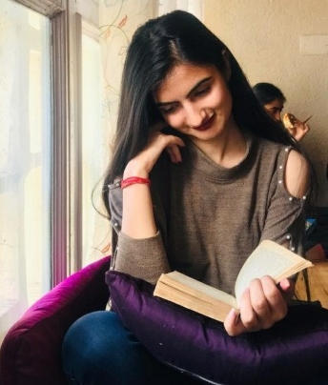
I will care for me.
By Mansi Singh Arora
Studying History Honors, Upcoming Author & Writer

*Healthy Lifestyle-II*

Hello friends, I’m here again to converse Healthy Lifestyle. Last month we had discussed how self care should be the first priority. Now we will see how to carry forward Healthy lifestyle for self and for our dear ones as well, by regulating our food in the correct way.

The diet intake is what makes us into what we are, by far! This is simply because everything about living is basically dependent upon the food; the product generated in the mechanics of life will be according to the raw material supply. A balanced diet is the very foundation of the healthy lifestyle we intend to achieve as it is this capital resource which is the energy source for every sector building life. Living is a composite thing and it is different from just being alive. Living comprises physicality along-with a lot of abstract features and aspects too; trust me, all of these is affected by our food intake!
Firstly, let us analyze the physical requirements: human body excluding the emotions becomes a functional machine. While some parts like lungs and stomach are on the job 24*7, many other parts
Squarepetals, Sep 2019

like eyes, limbs etc. have the leisure of some hours of rest during sleep. Thus, different organs perform functions independently, in addition to the combined functioning. So, food requirement of each organ is different based on its functions. Therefore, we need a balanced diet that fulfills nutritional requirement of the individual body organs separately and must suffice well for proper functioning of the whole body unit. A right combination of carbohydrates, proteins, vitamins, minerals and also water is the food input to get our body functioning at its best.

All the food components are equally good, proteins for instance are talked of highly, but if one consumes high protein food exclusively, ignoring rest of the dietary requirements, and assumes to stay fit depending only on proteins, I’m afraid, such an individual will be in a pitiable state. Let us simplify with the example of a car, this machine requires engine oil, gear oil and battery recharge in addition to the fuel. Fuel requirement is a regular feature and needs to be replenished more often, but still if engine oil or gear oil is not added in the little quantity required, the car cannot run. Similar is the case with human body.

Generally, food contains carbohydrates for energy, proteins for growth and the wear and tear, fats as reserve energy storage and a protective packaging to the bones so that skeletal framework is not broken easily. The fat layer beneath skin also gives shape to the body; attractive or otherwise depends upon our choice. Yes, contrary to other beauty aspects like skin color, shape of the eyes and facial features which are God given, the body shape is made by oneself depending upon the choice and frequency of food intake and exercise habits. So the three food constituents are macronutrients or fuel required by the body regularly. A person deprived of these will starve for want of basic survival needs.
Squarepetals, Sep 2019
Vitamin D is not available in common food but can be acquired with morning sunlight

Vitamins are essential micronutrients and their importance is commonly overlooked. So a reminder here that Vitamin A is very necessary for upkeep of eyesight, so keep eating yellow fruits and vegetables like pumpkin, musk melon, papaya and also carrots. Vitamin B complex set of 12, each has significance and any deficiency will cause fatigue and other symptoms affecting adversely the everyday work. Vitamin B complex is present in all the pulses. Actually speaking, the 12 vitamins of B complex and various amino-acids which make
proteins are distributed in a variety of pulses like gram, lentils, pigeon pea, chick pea etc. It’s okay to

eat tur dal often as choice of taste but make it a routine to also eat other pulses at least twice every alternate week. A mixed pulses meal occasionally is a convenient means.

Vitamin C can be supplemented with lime water. In fact, Luke warm lime water every morning serves also to detoxify. Seasonal citrus fruits after lunch, at least one per day is a healthy habit. But a matter of real concern is the deficiency of vitamin D very much prevalent among us. I’m afraid to say that many are not even aware that it can become lethal in extreme cases. Vitamin D is not available in common food but can be acquired with morning sunlight; ironically people suffer its deficiency because of the lifestyle today. Keeping indoors during morning hours and commuting in trains, buses and cars bars the sunlight from reaching us. Morning sunlight when falls on human body, acts on skin oils so that vitamin D is synthesized for body requirement. A balanced diet which is the required proportion of carbohydrates, proteins, fats, vitamins and minerals, and the morning sunlight dosage make it complete. However for those who cannot be blessed by sun’s rays every day, vitamin D is available in sea fish also.
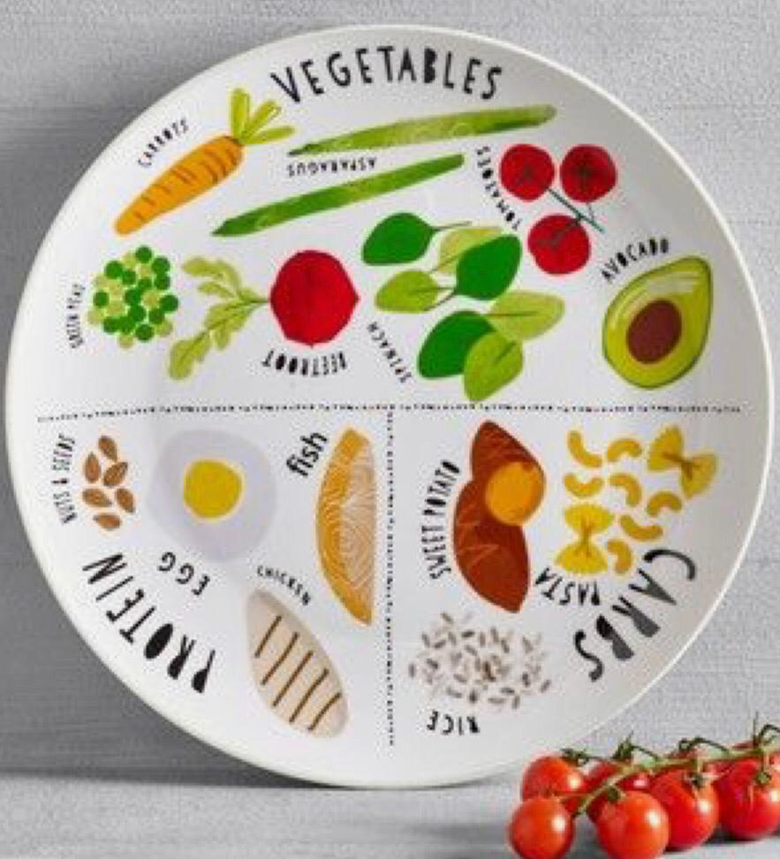
Minerals are micronutrients required in traces though, but an absence can disturb body functioning. One must therefore eat all seasonal vegetables, do not keep eating your favorite ladyfinger everyday thinking that as it is green vegetable so things are sorted out! You see, the cobalt is in broccoli and Molybdenum in the peas and zinc is in green beans. Minerals are distributed so we have to eat all the veggies. Iron deficiency creates blood shortage which is really drastic and an intravenous iron infusion is very painful as the liquid becomes thick so infusion rate has to be a speedy comparatively. It is therefore better to replenish it with spinach, apples and pomegranates. We must act wise as Health is Wealth. We can continue to work hard and create wealth, only when the health is supportive.
Absence of Minerals can disrupt body functioning
Do’s / Don’ts:
Do s :
- Wake up to refreshing lukewarm lime water or a lime tea to detox body system.
- Stay a while in morning sunlight.
- Choose a high-energy breakfast with fresh juice.
- Munch some dates and dry fruits in between.
- Prefer a light lunch, sprouts and salads.
- Take one seasonal fruit daily viz apples, grapes, oranges, bananas, also the less popular custard apple, peach and pear.
- Evening tea with fiber rich biscuits is good to relax. Like other organs, brain needs its own specific combination fuel. Also, do add Bay leaf while cooking, this is for the brain. Mental health should be a priority.
- Certain spices help secretion of enzymes. Try using jeera grains, fresh black pepper, cinnamon sticks and fresh turmeric roots. Use ginger and garlic in the raw forms, readymade pastes from the market should be limited in use. A pinch of soda bicarb weekly is good. Spices detox our system similar to the clean-up of carburetor to improve efficiency of a vehicle. Good dietary habits influence our capabilities similarly.
Squarepetals, Sep 2019

- A little flax seeds after meals support sound health.
Do Not s :
- Do not eat outside too often; it may cause coronary occlusion or heart attack. The triglycerides and cholesterol content is quite high in palmolein cooking medium probably used in some restaurants and food outlets. Restrict dinner outings to occasional celebrations. Happiness is another constituent of ‘food for the brain’ so it’s okay to enjoy sometimes, but don’t make it a regular habit.
- Avoid taking milk in the morning hours. Milk gets digested best when taken at night before going to bed.
- Dates are rich in iron and when taken empty stomach, help in losing excess weight but, at the same time an excess can create diabetes problems. So a wise balance has to be worked out. This goes for all the food as Calcium deficiency makes the bones brittle but en excess causes hypercalcimia and teeth may fall off then. A wise balance is therefore crucial.
- Rice for lunch makes one lethargic. Chapatti should be preferred instead. Dinner of rice is perfectly fine for a deep sleep.
- Avoid sugar coated mouth-fresheners. The natural ones like fennel seeds are better.

Finally an important fact, the dietary requirement varies from person to
person also, to some extent. This depends upon nature of work and the habitat. A laborer toiling hard to earn a living needs more stamina than the executive flying by air.
So the former needs a bulk intake of energy giving carbohydrates whereas the latter needs more exercise to stay healthy. Likewise, growing children need more protein intake; an obese child should be given fat free milk and so on. Take care to vary the diet a bit as situation demands.
We shall discuss about exercise and fitness in the next issue, but regarding food I would also advise that eat according to your surrounding climatic conditions also. When it is cold, take some jaggery in any form as it will pr0vide inner warmth, and during summers more of fruits and fluids help to maintain the body hydration.

I will sign off now, and we shall talk about ‘Exercise and Yoga, and some cool fitness hacks’ so stay tuned friends and keep smiling!
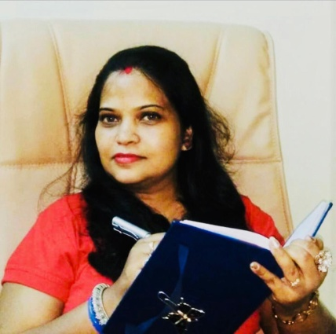

Sansriti Johri
Post Graduate in Applied Chemistry,
Author, Blogger, Columnist &
Social Worker
Squarepetals, Sep 2019

My Birdie Shall Fly Away
My wondrous eyes first on your countenance fell,
So delicate, so raw, and was under your spell,
Your teacher, your friend, your doctor or guide
With multiple roles, and always by your side,
But even with all these thoughts I knew....
My birdie shall fly away
Swallowing my fears, at the daunting task,
Gearing for times, my true feeling I’d mask,
Choose to be strict, when I’d rather be your ally,
Draw boundaries, when I’d wish you soar the sky,
All this to ready you for the life when I knew...
My birdie shall fly away
The time will arrive when, to bid adieu, I’ll face
With not grasping hands but those that offer to brace
Go embrace the world, with your new adult stride,
Forging new experiences without me on your side

Strengthening my heart, I prepare myself for when, My birdie shall fly away
Fresh respect for my mom, floods my being
The hard paths she took, I am finally seeing,
Full circle, on that same threshold, I perch
With mirrored emotions, her inside me I search,
All those times she might’ve said to herself,
My birdie shall fly away
And now when the inevitable is on the brink
I stand renewed with faith on our invisible link,
For wherever in the world you may roam
In my heart you will always be home
Now with wholehearted acceptance I say
My birdie shall fly away.

By Vidhya Krishna Raj
Editor, SquarePetals, Mumbai

Squarepetals, Sep 2019

Balance in Life
The Vital Aspects
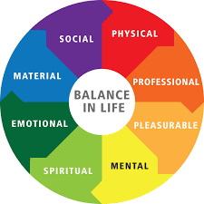
The only thing that we all want in life is ‘success.’ This word has been stamped in your mind since childhood; everyone around wanted you to be someone special in the field of ‘their’ choice. As soon as you were born, your horoscope was made to predict your future and dreams was created about you long time before you could even understand the meaning of success.
The load of success was put on your tender shoulders at a very young age, right from identifying your pre-school, school and then the college. Your family tried very hard to educate you and you received the message ‘Education is must to be successful’. Frequent exams and the marks you scored rated you as a poor, average or an excellent individual and you got the message that you need to perform to be successful. This era of performance was initiated when you were not even one year old; you understood that if you want to survive in this world you will have to perform.

You were listening to everything as a child and taking messages from the external environment which comprises of parents, elder siblings, teachers, friends and many other parental figures. Whenever you did not do well in your school, you criticized yourself saying ‘I am not good enough’ and when you did well, you were told there are many who are far better than you, so there is nothing to feel good about it which again made you feel sad about yourself. You started working harder competing with others to be the best. In the journey you forgot yourself, your own self, your own thoughts, feelings and desires. You forgot who you actually are, what do you want to do in life and the journey of pleasing others continued.
Squarepetals, Sep 2019
They were strong when you were a child, thus they were successful in influencing you
You learnt everything from your environment whether good or bad. You have acquired learning from all the elderly figures in the past, they were strong when you were a child, thus they were successful in influencing you. You also understood that ‘performing in education is the way to success.’ You began your journey of success with the conditioned mind and started operating from whatever you learnt and you gave up all your desires and dreams. Pre-school to school, school to college and then into job, you were in the race of doing the best and be successful.

The day came finally when you are doing a job and you acquired all the luxuries, a big bungalow, a car and lot of money to buy anything in the world. You are successful as defined by others in your childhood, but it is strange that even though you have everything now, still you don’t feel happy as you are not satisfied. You realize that the comforts and luxuries earned are not influencing your life anymore.

The popular saying ‘Money doesn't buy happiness’ is it really true, you are questioning self. Money has brought to you all the comforts of life, but not the happiness! The definition of success which you were taught was ‘to earn more and more money and comforts’, but it actually doesn’t seem to be working! You have everything in life yet you are not happy…. what went wrong? Why this feeling of unrest is there? This is the question that many of us are puzzled about. Why do I feel discontented still in spite of achieving so much??

As a matter of fact, you have invested so much time in earning the luxuries of life that you missed on many other aspects of life which give balance to your life. Just as you need a balanced diet to keep you healthy and strong, same way you need to create a balanced life to remain happy and satisfied. If you overdo on any one aspect of life you lose out on the rest, and this may disturb the balance in your life.
How to create a balance in all the aspects was never taught to us in any school. Here I will put forth the main aspects that bring that right balance in life.

The most common aspects are:
1. Business / Career
What careers you are into, what do you do, are you enjoying the work? Are you in this career by luck or by choice? Are you earning enough to fulfill all your dreams and aspirations of life?
2. Money
Do you have sufficient amount to fulfill your basic needs of life? Do you have heavy debts? Have you taken many loans? How do you feel with the amount of money you have?
3. Relationships
Do you have cordial relationships with your family and friends? Do you have trustworthy people around you? Do you accept people unconditionally? Do you have supportive friends? How much time do you spend with your family and friends?
4. Health
Are you overweight? How do you feel about the overall appearance of your body? Do you eat healthy food? How do you feel about your mental health? Do you have a positive attitude towards life? Are you taking any medicines? Do you go for regular medical checkup? Do you exercise regularly?
5. Personal Development
Do you feel you are growing in life? Are you open to learning new things? How do you deal with your learning process?
6. Love Do you feel loved? How do you express your love towards your spouse and other family members? Do you feel connected to your family? Do you have
Squarepetals, Sep 2019
a committed partner? Are you committed to your partner?

7. Fun
Do you enjoy in life? Do you go for outing with your partner and other family members? Do you spend quality time with your family? Do you take out time and enjoy with friends?

8. Contribution
Do you help others? Do you support in the growth of your family members? Do you volunteer outside your family and extend support? Are you a part of any social clubs?

All these aspects influence the life of an individual; if you really want a satisfied and a happy life, reflect to each of these aspects carefully. Think over where you stand in each aspect and where you want to reach. You may also want to see where the major stress zone lies and which aspect needs to be concentrated at this particular stage of your life.

Since childhood we were trained on the one aspect which is business / career. No school or college has taught us the importance of the other seven aspects. We have either not learnt about the other aspects at all, else we may have come across a few from the environment on our own. We have never been trained on these aspects formally, and therefore people are mostly struggling and feel dissatisfied and unhappy in life. You may be extremely satisfied with one aspect but at the same time you may be struggling with other aspects of life.
Once you ensure that all the aspects are well connected to you, you can create the right balance in life to be happy, successful and contended. The parents, teachers, coaches and mentors should therefore nurture the younger generation in all these aspects of life and not over stress in one direction only to be successful and happy in life.


We are starting a separate column in this magazine to address to your concerns in life. Do send us your concerns where you are feeling any stress in your life. We will answer all your queries in our next issue. Feel free to write to us: info@esquire-vj.com, we are here to support you and guide you. Let us talk and sort things out for a happy living.

Kavita Hans
Life Coach / Author / Motivational Speaker
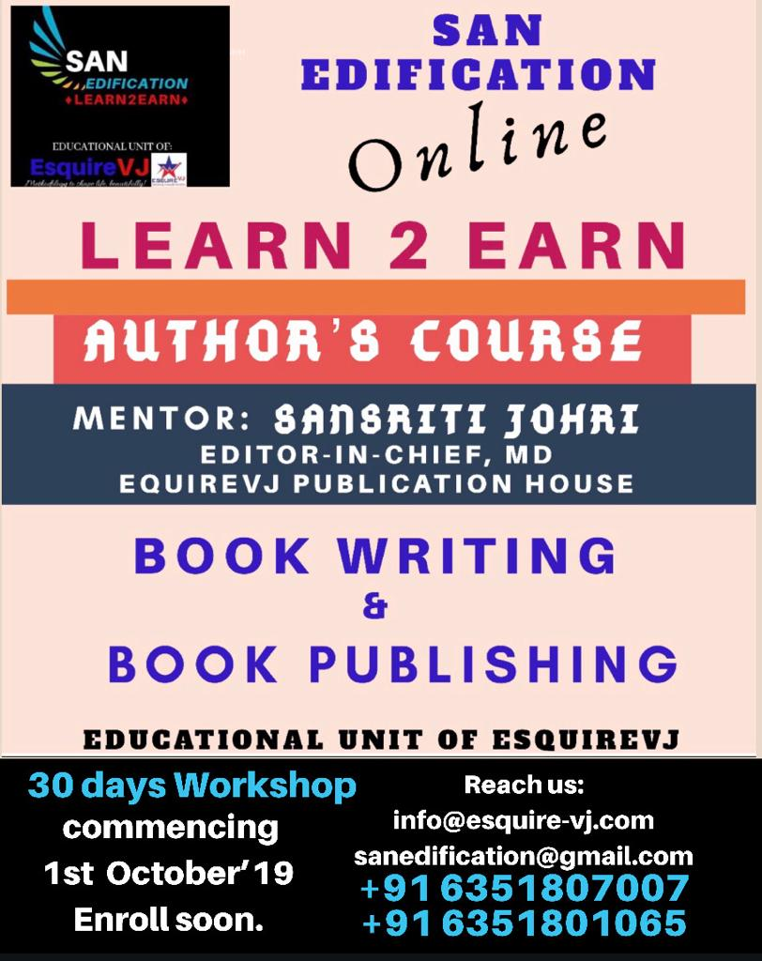

Squarepetals, Sep 2019
MIRACLES happen,
If you believe
Sir Albert Einstein had once said, "There are two ways to live : We can live as if nothing is a miracle, or else we can live as if everything is a miracle." I believe in the latter mostly, living like everything about life is a miracle. I feel that miracles happen all around us, even though it’s difficult to notice them sometimes.

The first time when I experienced a wonderful miracle was during a train journey; I was travelling from Visakhapatnam to Berhampur, my hometown after 2 months as I had been staying at Vizak to complete my college education there. I had started to feel bit sleepy sitting idle in the sleeper coach when suddenly I heard some chanting from a man. As I opened my eyes, I saw a man about 35 - 40 years of age, chanting some shlokas of Lord Shiva, and I thought he must be a beggar; I was going to give him some 10 rupees, but surprisingly he came and sat beside me! He smiled at me, and I reciprocated. He continued his chanting, disturbing my sleep totally and so I decided to sit up and listen to some music. He started observing me and asked me in Hindi, “Hey boy I am getting bored will you introduce yourself to me?”

I was quite impressed on hearing his gentle voice and the warm expression on his face. I completed my introduction and then he smiled again, so I asked for his introduction also politely. He started talking about himself very humbly and in a down to earth manner. Although his looks were quite plain, he was a young Swami of the Iskon temple from Mathura and when I observed some of his core values, I was totally mesmerized and got inspired by him. He enlightened me with his knowledge and understanding of God and super natural powers, and I got engrossed in the topic.

The 3 hours journey from Visakhapatnam to Berhampur got over in no time listening to Swamiji. He showed me some photographs of Gods and Goddess in various temples across the country, specially mentioning about Puri and Lord Jaganath (Lord of this Universe). I too thought about sharing with him some of the famous temples in my hometown. I showed him a picture of Goddess Brahmapur's Thakurani Maa as I was having it in my wallet. He was very happy when I gave him that photograph.

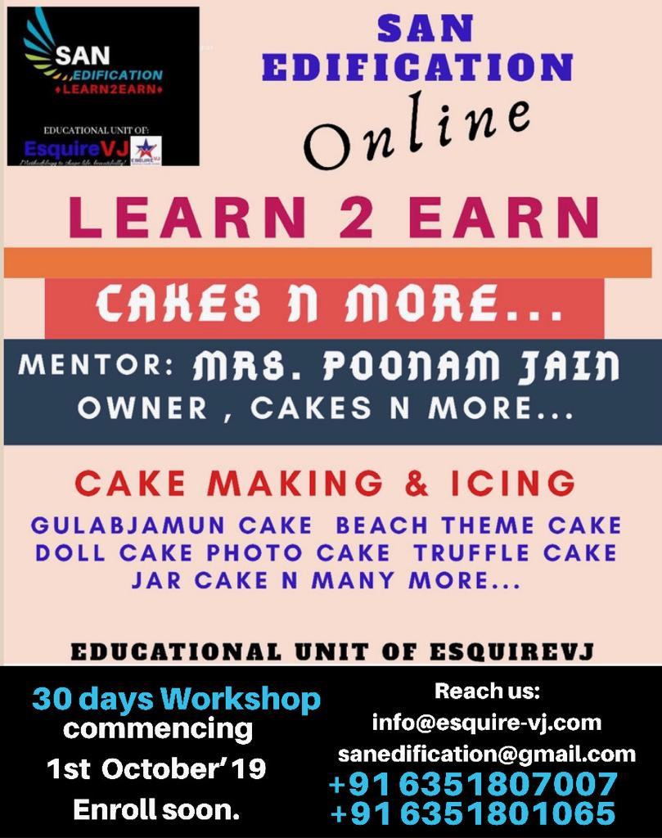
After a while I was about reach my destination and so I excused myself cutting short his conversation and I started arranging my luggage. Before I had left, he told me something which is the best quote I have ever known and I could never forget it in my life. He said, "Have faith in God and see how you cross miles in no time, be good and God will lead your way”. He then went away from me and for a moment I felt spell bound just watching him disappear as I reached my station.

I kept on wondering later on who could be the holy man I had met that day. He taught me important lessons of life in just 3 hours but did not reveal his name while telling about himself; he sort of practically proved it to me how the long tiresome journey of life becomes simplified and interesting by the guidance of God. Did I meet the Lord himself that day? Well my conscience says it all! It was a wonderful Miracle which I experienced. I believe I had a great conversation with the Almighty.

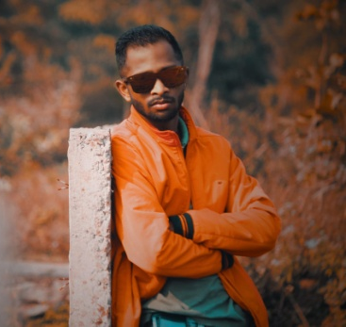
By SAI SRITEESH JAMMULA
Perusing B.tech (Civil Engineering), Writer @ a vivid reader
Squarepetals, Sep 2019

Vastu Science
The Essence of Well-being.
Vastu Shashtra is based on the science of construction or the architecture, and it is a system of design based on directional alignments. The rules of vastu are based on scientific principles and the meaning of the term ‘Vas’ is residence or ‘Nivas’ is to live, whereas the meaning of the term ‘TU’ is the eternal Lord, The God.

Vastu Shashtra unifies the science, art, astronomy & astrology which form the ancient mystic science for designing and building. Vastu shashtra helps to make our lives better by providing security from all sorts of negative energies. Vastu is a part of Vedas, which are believed to be 4-5 thousand years old. It originated precisely in the Stapatya Ved, which is a part of the Atharva Ved.

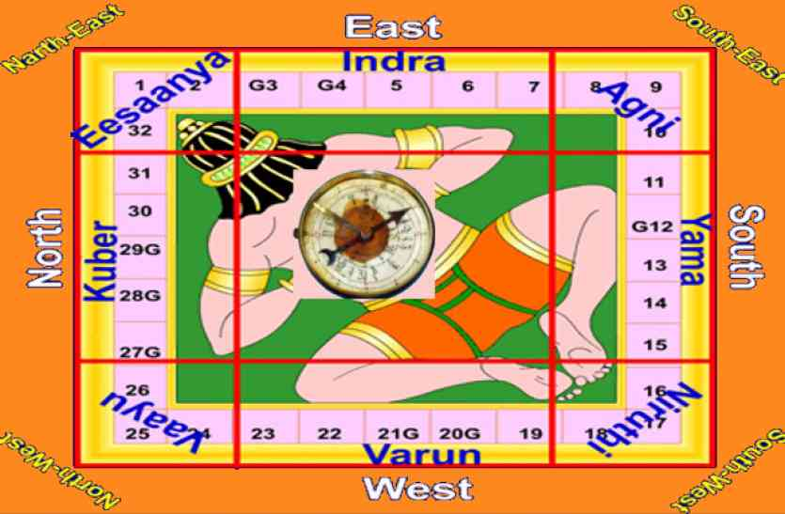
According to Vastu Shashtra the world comprises of 5 basic elements known as the Panch Maha Bhoota. Of the existing 9 planets, only the earth has life on it because of the presence and balance of these 5 elements
namely, Earth, Fire, Water, Air, Sky (Space). Vastu Shashtra provides information whether a building, a residence or premises is properly constructed or not, and helps in identifying the faults, if any. It inspects all the aspects from land to the others as water, road direction, the atmosphere to detect if any danger is around. Thus Vastu can help us in leading a more balanced life of contentment and bliss. Even if you are not building a new home or office you can apply the Vastu principles to the existing setups for improvements.
Squarepetals, Sep 2019

Vastu works on the faith that earth is a living element out of which other living organisms emerge, and this life energy is known as Vaastu Purush. The Vastu Shashtra works for bounded premises i.e. a house, building, industrial area or a shop. The main aim is therefore to create a balance between the outside atmosphere and the atmosphere within the premises.
For the study of Vastu it is necessary to understand the Vastu Purush, which is signified by a Human body sleeping with its face towards the soil; and an examination of his limbs with respect to direction. Therefore, Vastu Shashtra is connected with Physical Science, Mathematics, Sculpture, Architecture, Engineering etc.

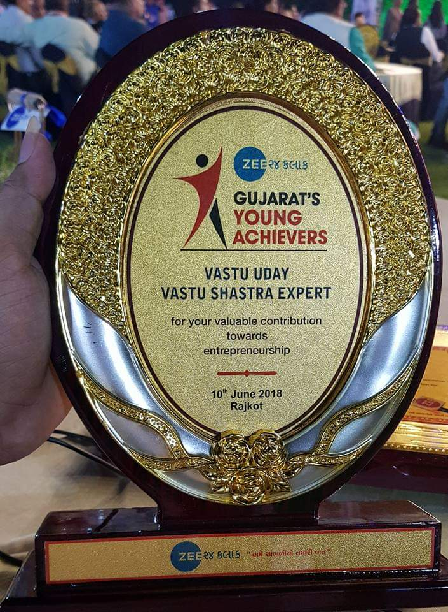
Many a times there happen to be such faults in the construction of houses and office buildings which adversely affect the well-being of the inmates. Unfortunately, people are mostly unaware about it. At the same time it is not practically possible to alter the construction once it is done; therefore a major need today is the correction of faults in the vastu of buildings or houses, without any demolition or reconstruction.

If a building is constructed in harmony with the rules of Vastu Shastra then the inmates make progress in every walk of life and become wealthy. We also get mental peace, happiness, satisfaction, knowledge, health and good fortune by following the basic principles of vastu in a construction, Stay Tuned & Stay Blessed. Nikesh Rajendra Soni- Niky Vastu Consultant

To get personalized Vastu tips, suggestions for Vastu Correction about your House/ offices/ shops by Professional experts write to us: info@esquire-vj.com
Or call up +91 6351807007 / +91 7698055502
Squarepetals, Sep 2019

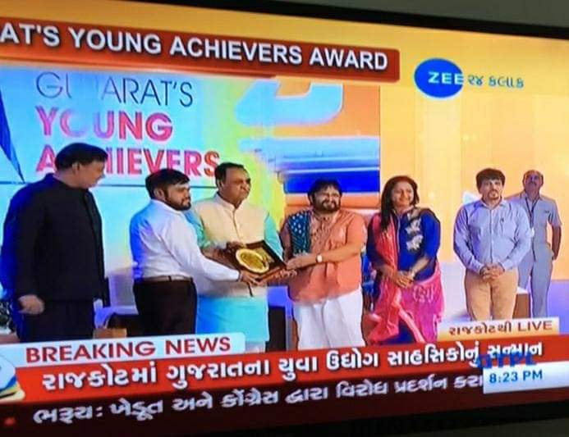
Next month we will discuss more about the five elements and the right locations, and also about the birth of Vaastu Purush.

Veggie Fish ... Lazeez !!

Ingredients:
1)Gram flour - 2 cups
2)Mustard oil - for deep fry
3)Mustard seeds - 4 teaspoons.
4)Garlic cloves - 8
5)Red pepper - 4
6)Lime - 1
7)Tomatoes - 4
8)Turmeric powder - 1 teaspoon
9)Fenugreek seeds - half teaspoon
10)Salt - as per taste .

Method:
1)Garlic masala paste: Grind together in a mixer the mustard seeds, garlic cloves, red pepper and a little bit of turmeric powder. Keep it aside for sometime.

2)Preparing the besan fish : Mix the gram flour with some water and make a smooth paste. Then add 1 teaspoon turmeric powder to the paste and salt as per your taste. Mix it well.
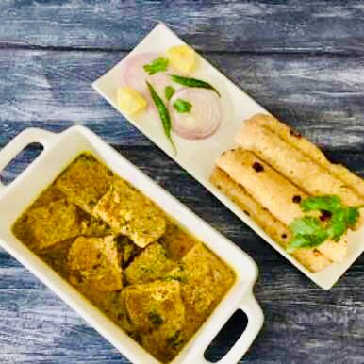
Now put a non stick fry pan on medium flame and place the paste in it. Heat while stirring it continuously till the paste dries up a to a thicker consistency as it should not drip down from roasting sticks.
Squarepetals, Sep 2019
Take roast sticks and put the thick paste on it, then leave the sticks for cooling down a bit. Now cut out the deposited gram flower paste from the sticks carefully, in the shape of small fishes. Fill up the hole in the centre of your veggie fish with the garlic paste you have prepared. Now deep fry these pieces and keep them on a side.

3)Preparation of gravy: Heat little oil in a frying pan. Put some fenugreek seeds and then add the remaining garlick masala paste to it. Heat it then add chopped tomatoes and salt to taste. Now add water after a few minutes and bring the mix to boil for gravy.
Now add the dry stuffed veggie fish to it and boil for another five minutes. Switch off the flame and squeeze one fresh lime in it.

So your veggie fish dish is ready! Relish it with chapati or rice, and don’t forget tell me how it was!!
Annapurna Verma
Cooking Expert & Mentor, Mumbai

Squarepetals, Sep 2019

Squarepetals, Sep 2019
DahiHandi Fun !
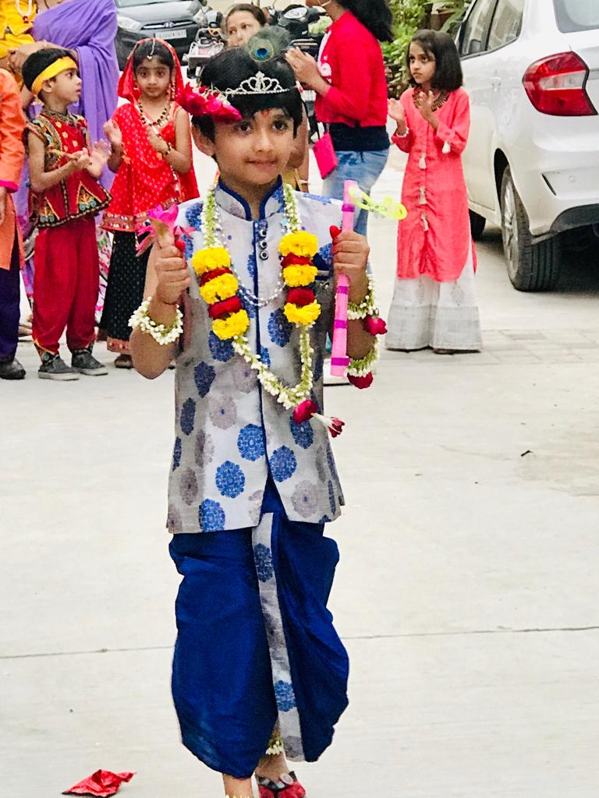
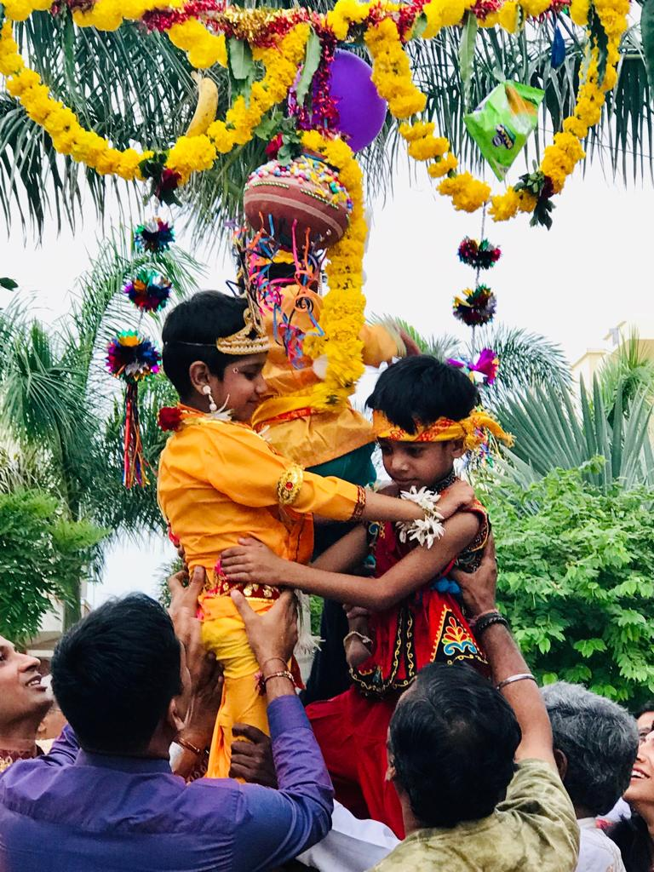
Like every year we celebrated the birthday of Lord Krishna, it was on the 24th of August this year and there was a current of joy in my society as people were busy planning the preparations for the evening. The men were running around arranging for ladders & ropes to tie up the handi, the women were giggling and gossiping while painting and decorating the handi with glitters and flowers. The kids were deciding upon the list of eatables to be filled up in the handi; festivals bring people close and this becomes another reason for celebration.
Janmashtami celebrations are a blast of fun as it is followed by the popular Dahi Handi ceremony on the next day, which has been my favourite always even though I have almost broken my bones many a times in the desperate attempts to grab the handi with the goodies, hanging sky high; it’s so tempting I swear!

A small earthenware pot called the handi is filled up with butter & sweet curd, also with sweets & chocolates these days and then it is hung up high from the skyscrapers!! We young boys are then
Challenged to reach up there and break the handi by hitting it with a coconut so that we can then enjoy the yummy treat inside it, just as the naughty Krishna used to secretly finish off butter & curd stored in the handy by his mother with his gang of friends. Thrilling, isn’t it?
Squarepetals, Sep 2019

Not only that, the women compete by creating hurdles to prevent the guys from getting the handi; they throw bucket full water upon the boys who are already struggling to form a pyramid like formation by climbing one upon another, in order to fetch the handi. Krishna ! Krishna!!
People burst laughing each time the guys topple down with a ‘thud’! They keep falling off repeatedly for hours but don’t give up till they finally fetch the handi and then they scream with joy and rejoice.
Every teenage boy is a loving Krishna, smiling innocently with butter all over his charming face, as the city streets become a Vrindavan during the vibrant Janmashtami celebration.
By Shashwat Johri
Best Debut Indian Author
Amazon Best Seller

POWER OF SELF DISCIPLINE
Self-discipline is the commitment to do what is right even when you don’t feel like doing it. Self- discipline has a great impact on your future and in your work. Without a high level of self-discipline, it will be difficult for you to realize and maximize your full potential.
History reveals that all the outstanding leaders and achievers of the world understood the value of self-discipline in life. The Greek philosopher Plato asserted, “The first and best victory is to conquer self.” The battle of self-discipline is won within and the greatest victories are internal ones. The famous mountain climber Sir Edmund Hillary observed, “It’s not the mountain we conquer, but ourselves.”

Success cannot be achieved without self-discipline. The reason why some people are never able to accomplish much in their personal and professional life is lack of self-discipline. Self-discipline requires self- control, and by practicing it, you become more productive and confident, you become a better and a stronger individual. You also develop high level of self-esteem, self respect and personal pride.

English theologian and orator Henry Parry Liddon observed, “What we do on some great occasion will probably depend on what we already are; and what we are will be the result of previous years of self-discipline.”

The power of self-discipline leads you onward and upward to great success and a continuous and consistent practice of self-discipline enables you to gain capabilities and utilize them to the maximum potential. The exercise of self-discipline has a powerful effect on your mind and emotions, developing you into a better person from the one that you would have been without self-discipline.

Imagine yourself in a chemistry lab. You mix a series of chemicals in a Petri dish and put it over a Bunsen burner. The Bunsen burner heats the chemicals to the point at which they crystallize and become hardened. Once you have crystallized these chemicals using intense heat, they cannot be transformed back into liquid form. In the same way, your personality is like a liquid initially: soft, fluid and formless. As you begin to apply the heat of self-discipline, you expertise in doing what is difficult and necessary rather than what is fun and easy, your personality crystallizes and hardens at a higher level than before.
Squarepetals, Sep 2019

The greatest benefit you derive from exerting self-discipline in the pursuit of your goals is that you become stronger and more resolute. You develop greater will power and determination. You actually shape and strengthen your personality and transform yourself into a better person.

The rule is that, ‘To become someone that you have never been before, you must do something that you have never done before.’ You must develop a high level of self-discipline in every area of your life.



By Michael Ediale
Life coach, Mentor
Bestseller Author on Amazon
Squarepetals, Sep 2019



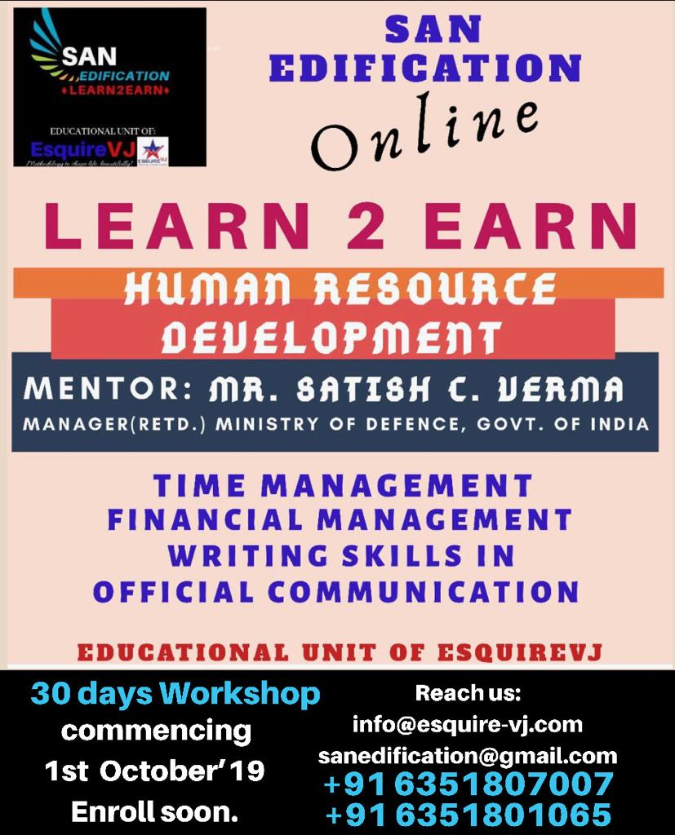

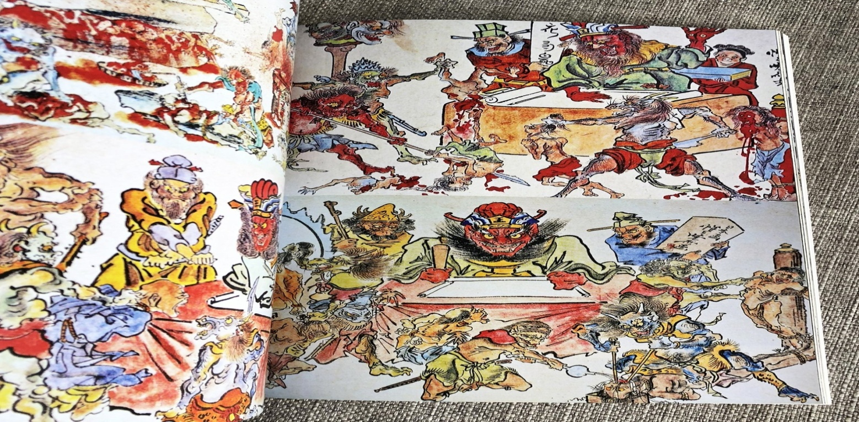

The Night of Hell
A Guns of Vengeance Short Story

I am writing this story down so that while I remember it and for others to understand. This event happened one year before the civil war started. I was working as a town deputy at Red Bluff in the Kansas Territory. I was riding out of town to track down an anti-slavery troublemaker named Charles Davis. It was October 31, 1859, and as I rode through the barren Kansas landscape after four hours I came across a Victorian house. It looked like one of those old fashion New England places and I had a question why was it here.
Since the sun was going down I decided to make camp, eat breakfast and go to bed. It was one a.m. when I saw lights lighting up the sky and when I got up that house was on fire. I realized that since no one could survive that I turned around and went back to my bedroll. I got up about 6 a.m. had breakfast and as I mounted my horse I saw that the house was not charred remains.
Squarepetals, Sep 2019

I decided to find out what was going on ignoring the feeling of dread. When I was 1000 yards from the house my horse got panicky and

threw me and the last thing I remember was hitting the ground and everything went black. I woke up tied between two pillars by ropes stripped to my waist. As I looked around the dark room I saw a cauldron on a fire and implements of torture on the walls and two witches.
Both women had hooked noses with the wart at the tip and black pointy hats and black robes. I never felt fear until now. They were speaking some weird language over the cauldron and I felt a very cold evil seeping in. One of the witches who had grey dirty hair looked at me and said, “You were warned young man to stay away. Now you will pay with your life and our brothers and sisters in Salem will be avenged.”
I was tied up wondering what the hell was I going to do. The other witch held a knife and was looking at me and was mumbling something over the fire and it didn’t sound nice. I knew what was happening, but my mind didn’t want to consider the truth.
I slowly tried to loosen the ropes and for a minute I was succeeding. The second witch saw what I was doing and said, “I see what you’re doing and I am getting stronger ropes; you will die.” Just then a rat jumped on my arm and when she got closed I held my arm up and the rat jumped at her and she screamed jumping back and tumbled off the stairs knocking the cauldron over and the house went up in flames.
I got loose and was running to the door and it wouldn’t open. As the fire got closer and closer I could feel the heat and when it got two steps from me I passed out. I woke up feeling cool water o my lips and opened my eyes to two twenty-year-old women standing over me. Both were wearing clothes similar to what they wore up in New England. She looked at me and said, “Your horse threw you and we followed him back here. I got up as they smiled at me and the blond woman said, “Thank you for freeing us.” They both kissed my om the lips and when I turned around to look at the remains of the house it was gone. I turned back to the women and they were also gone. I decided to ride back to town and realized that no one would believe me, not at least till Halloween of next year



By: Douglas Sandler, Author,

Women humiliation..
Squarepetals, Sep 2019
A Social Concern
Sita’s ordeal, Draupadi’s rip off attempt, husband’s adultery or the society’s crooked treatment, harassment by men or fear of triple Talaq...
Women have been living in the shadow of the fears of humiliation.
The dignity of women is important for the progress of a healthy society and a strong nation,
but to-day, they are struggling and the anecdote they face are beyond narration.
Violence, slavery, rape , sexual assaults and even forced prostitution sometimes! Needless to mention, they are scapegoat of honor killings, immolation, and genital mutilation,
Most unfortunate often they are victims of gendercide of girls and selective female fetus abortion.
This is happening in many countries of the world. It is disheartening the way men treat girls and women with indignity and discrimination.
It’s a serious social and humane concern, we all pledge to bring a big change to stop women humiliation.
To some extent the women too are guilty as they silently bear all torture with aghast toleration.
Now, the time has come, for a befitting strong reaction; today the women should stand united with courage against any such injustice or harassment being caused to them and the society should take up the responsibility to honor and protect our women, this is important for a better world and a better tomorrow.
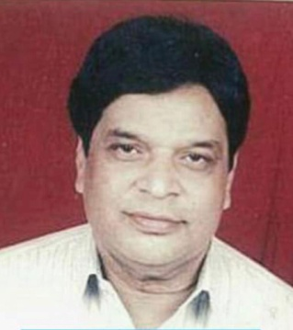

Mr. Satish C Verma
Award Winning Author & Editor

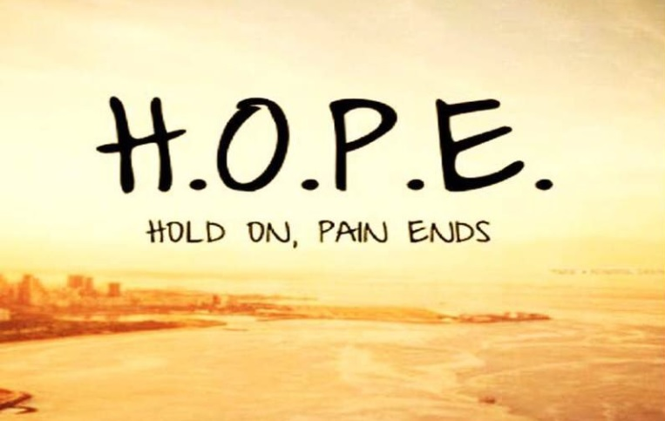
Hope
Just as I thought that I had an end to the dreadful day. I came back home to no sound of my mother, indicating we were still fighting. I gulped down my food in agony hating myself, thinking about was I really wrong?
"I have done everything that they have ever asked for", I thought. All I wanted is a nice little conversation about how each ones day was, sitting together in the living room at the old brown couch which was now covered with dust.
Adulthood really taught me how to not care. But somewhere deep down, I still did. Swallowing each bite of food without even tasting it, I finished my laid out food as soon as I could and marched to my bedroom. I propped myself on to my bed, switched on the table lamp and waited till that feeling of loneliness and failure started crowding my thoughts. It was fourth time this week and I was at the verge of an anger episode. All I needed was a break from reality. Just as the thought crossed my mind, I walked back to the living room put on my grey sneakers and walked out of the door yet again for the third time today without saying a bye. Tears threatened to burst out as I impatiently waited for the elevator looking towards the apartment door with the hope that someone would come out and ask me that what went wrong or talk with me instead of letting me be alone. A loud ping from the elevator made me jump as I finally looked towards the ivory colored door with the last inch of hope left in me and shut the double bars behind me.
I tried not to breakdown and walked out of my building silently fake smiling to people who didn’t even care about my existence. I rushed out of the building, on to the same route, that I always took to clear my head. After passing endless number of vehicles and listening to the continuous honking through the loud music blasting from my ear pods, I wished to get hit by the large truck painted ocher color with dabs of green that just passed by me. This reminded me of my life as to how little had I left to hold onto. It reminded me of autumn where only a few green trees swayed in hope on the barren lifeless ground with leafless trees. Comparing my condition with that of a season almost made me choke on my breath until I realized that I was already crying. Pain of the failure was not understood and was truly unbearable.
Squarepetals, Sep 2019
One thing that continuously hammered my head was where I went wrong!? Why did I go wrong?
Wandering mindlessly for about a quarter hour, I subconsciously reached to the old spot where my happy and sad moments met to make amazing memories.
It had been ages since I had been here.
After that day I had sworn to myself that I would never come here again. But yet here I was, contemplating about whether or not should I go inside. The energy of the place pulled me towards it. Just as I decided against it and started to walk away from the temptation, it started to pour heavily. "Damn!” I mustered under my breath. I pulled up my hoodie and ran towards the attic, my old sweet spot. By the time I reached the safe spot, my sneakers were covered in mud and now I would have to wash them. Looking at the rain drops pour down the moss laden walls along the climbers, I thought about the fate of the rain. There were climbers and mosses with green lush grass all around now, because of the rains, which made the attic look even prettier than usual.
This attic was an old place not looked after by anyone. It still was pretty on the inside and creepy on the outside. It had two huge metal bared doors now covered with cobwebs and rust. It would squeak loudly every time the door was moved. It reminded me of the times when I would sneak out of the house and get scolded each night by the old man who stayed the next door.
Wondering about how my life could be and how it has become made me pull out a cigarette that I brought from the shop and the corner of the road. Just as I pulled it out and placed it between my lips. I searched for the light. "Damn me did I lost it somewhere? Or did I drop it somewhere", I thought. Unable to decide what it was just as I was about to throw the unused cigarette in the bushes. An unknown voice startled me.
He asked, "Need a light?"
Who was this man? Was he following me? Or was I just being paranoid.
Who else knew this place?
I tried to peek a glance to his face but it was too dark.
I thought to myself that maybe taking up his offer to light I might be able to catch a glimpse of his face.
"Sure" I replied.
Pulling out a lighter from his pocket he lit two cigarettes one for me and one for him.
In that fraction of the light, I saw his smooth yet tensed face. He didn’t look familiar to me at all. His hair was pushed back from his forehead, they glistened in the light implicating that he was drenched in the rain too. His perfectly almond shaped eyes didn’t have life in them just as mine didn’t. He was reflecting my soul through his hazel brown eyes. His nose was that like a perfectly carved statue. And his lips were perfectly chiseled, in a complete straight line. His face didn’t give away any emotion. Just as he handed me handed me mine. I was pulled out of the thoughts. My mind no longer wandered it was only concentrated on the one person. Who was he?
We sat in complete silence for about half a quarter minutes. Apart from the drops of rain crashing against the half broken shed, the silence grew more uncomfortable. I pulled out my earphones and played on my favorite number. With each drag of the tar that I drew in, my nerves grew calmer. "This is it", I thought to myself. "This is what I wanted." It was almost getting quite the rain was about to stop. It was lightly drizzling I decided to leave having one last glimpse at my intruder. Just as I was about to step out, he spoke
"It’s hard to see the brighter side when you can only see the dark all around, don’t you think?"
"I agree", feeling the intense need to share his pain. There was something about him that wanted me to know about him.
Squarepetals, Sep 2019
"Do you come here often?" he inquired.
"Do you?" I countered back. Why was he so inquisitive?
"That wasn’t the answer to my question", he said, "never mind though" he chuckled.
I failed to find humor out here, what the fuck was funny? Do I look funny? But wait he can’t see me.
"That wasn’t the answer to my question as well.” I replied a little irritated. I turned back to walk out.
"I come here often!" he replied in a defeated tone.
"Okay!"
"Will you be here tomorrow too?" he asked.
"I don’t think so, I don’t come here often, it’s just because of the rain" I replied half heartedly not giving away the entire truth.
I wasn’t planning on coming back here. Not now, not ever. The peace that this place gave me was almost deafening to my soul. It made me want to hope, when I had none left and this hope is what made me weak in the first place.
"It was good meeting you” I said and turned to leave. This time I wasn’t stopped by his words. He sat there in silence smoking his third cigarette.
Walking back home chewing on mints, I carefully entered my bedroom hoping to get through without getting spot by anyone.
To my good luck I didn’t. I changed into my comfortable pizza printed pjs and a panda t shirt, and went straight to bed. That night, after days I had a peaceful sleep with a pleasant dream. My dream was clouded by the strange man who I met today and the way his voice sounded, the way he talked, and the way he sat there without moving. My thoughts wandered about a zillion possibilities of his condition.
Just as I was coming to certain conclusions about his condition, the alarm clock brought me to reality."Argh" I thought to myself. "Why was I dreaming about him?" I was both grateful and shocked. Grateful because I didn’t have to deal with one of those horrendous dreams; and shocked because I had dreamt of someone in quite long time. I was grateful for this day. The depressing thoughts about yesterday were making its way out of my head. As I got out of my bed thinking and promising to myself that this would be a good day. I slid the curtains to both the ends trying it together. Opening the window and taking in the fresh morning air hoping it to be a good day. I stood still by the balcony basking in the morning sun which felt oddly comfortable and yet again tried to cling onto the hope that was now trying to break in through the cracks in the wall that I had built around me, after my yesterday’s reckless visit to the attic.
Squarepetals, Sep 2019
The day passed by like usual, avoiding eye contacts and drowning into the work. I didn’t even realize when the day passed by thinking about the mystery man. Today, I didn’t decide on going home. I decided to directly head to the attic.
Walking carefully through the mud in my 4 inched heels and a dress was more difficult to manage than I imagined. Finally making my way up there I saw a note. "Thought you might need a light- stranger. :)" there was a packet besides it. It contained a box of cigarettes and a lighter.
It was my lighter the one that I had lost on my way here. It looked a little different. It had letter "A" engraved on to it. Just as I opened up the box to remove a cigarette. The lid of the box read. "Cling on to the last bit of hope you got and you will get through."
This man whom I had met less than 24 hours ago was able to knock those walls down. I visited days after days to the same place, in hope that I would see him again, but I never did.
It has been 3 months and I still visit that place with a hope in my heart that maybe one day I could meet him and thank him for the hope that he brought back into my life. I guess, after all, hope is always the thing that keeps you going.

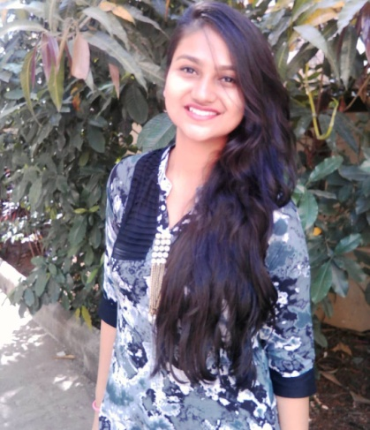

By Jahnvi Doshi
A Bibliophile, Double graduate (Micro Biology & Chemistry,

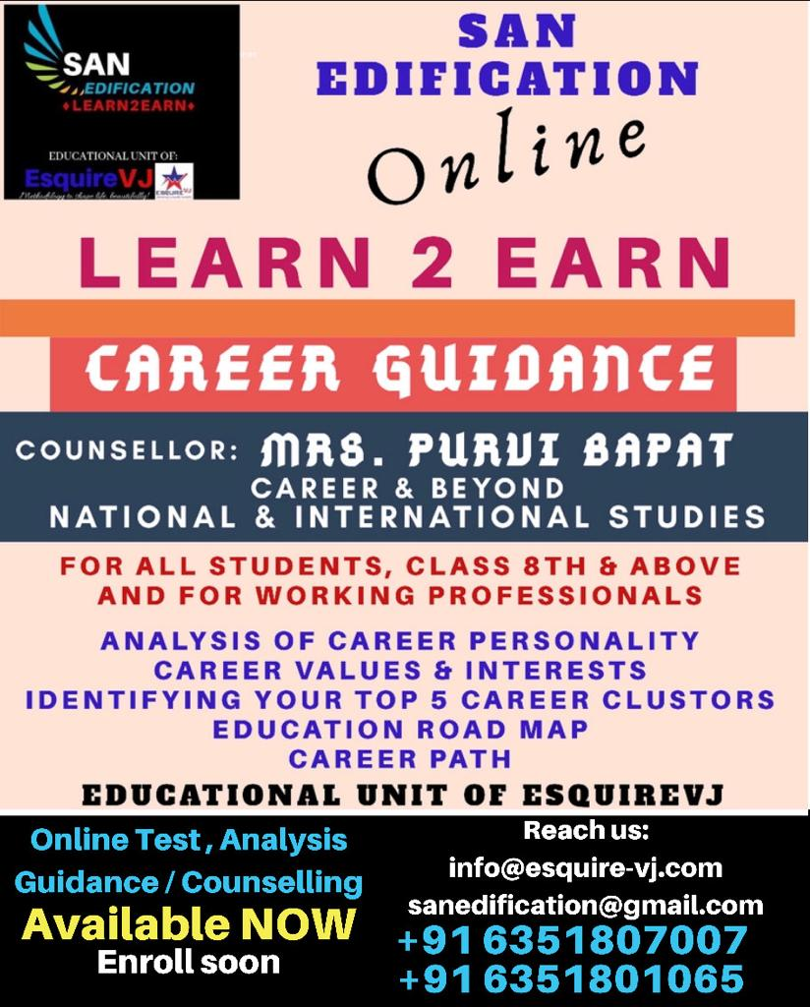

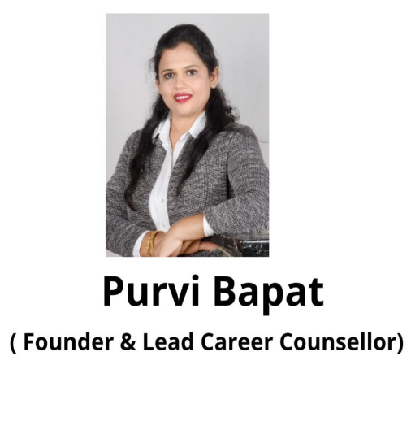
Career Counseling

Squarepetals, Sep 2019

Each one is born with specific skills we all know, but what’s your forte do you know?
Our inherent capabilities are mastered through education in that specific field. Also the choice of the individual plays the key role in performance. Selecting the right field of study based on the inborn skills and choice of field, is what gears you up for success. A mis-combination results in career disaster as seen in many cases where people with highest education remain jobless or discontented.
Therefore act early and act on time, take up the Career Profiling Test and move ahead accordingly with confidence and happiness.
Write to:
info@esquire-vj.com
and enroll now!







Squarepetals, Sep 2019

